Sort an array of 0s, 1s and 2s.py

<https://github.com/ejacobs32/SDEV-220-Homework/blob/main/M03/Sort%20an%20array%20of%200s%2C%201s%20and%202s.py>

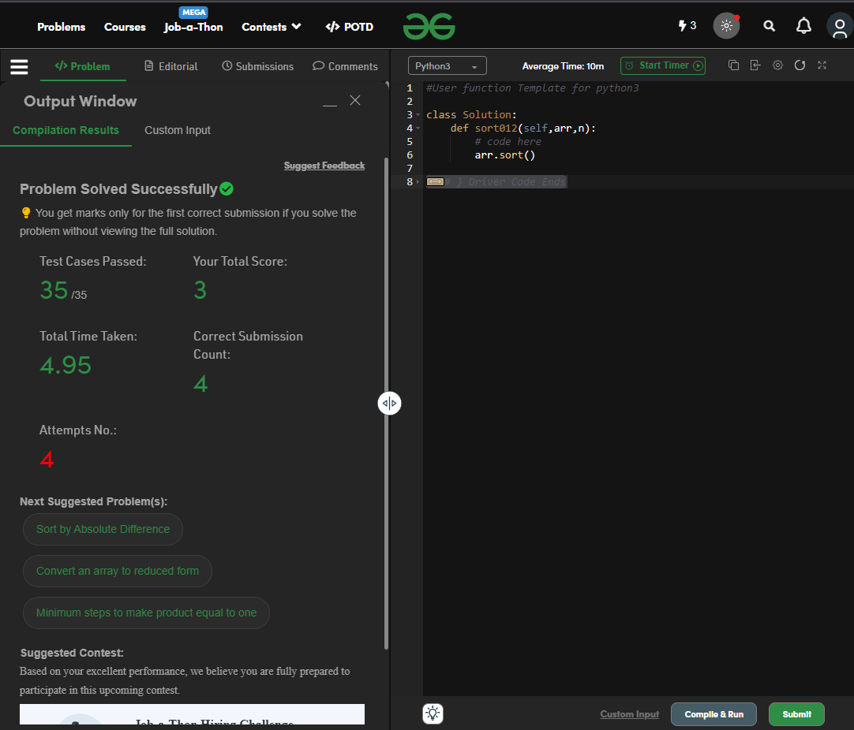

Binary Search.py

<https://github.com/ejacobs32/SDEV-220-Homework/blob/main/M03/Binary%20Search.py>

